**Practice Exercise**

Sub: Principles of Finance Date : 13-06-2018

Name: Roll. No.

1. Prepare the income statement of a firm which gives the following details relating to its operations:
2. Operating Leverage-- 4
3. Financial Leverage – 2
4. Annual interest paid—10 lakhs
5. Tax rate—40%
6. Contribution/Sales – 0.4
7. . A company has on its books the following amounts and specific costs of each type of capital.

|  |  |  |  |
| --- | --- | --- | --- |
| **Type of capital** | **Book value** | **Market value** | **Specific cost of capital (%)** |
| Debt | 4,00,000 | 3,80,000 | 5% |
| Preference | 1,00,000 | 1,10,000 | 8% |
| Equity | 6,00,000 | 12,00,000 | 15% |
| Retained earnings | 2,00,000 |  | 13% |
| **Total** | **13,00,000** | **16,90,000** |  |

Determine the weighted average cost of capital using (a) Book value weights and (b) Market value weights. How are they different?

3. The current market price of the shares of A Ltd. is Rs. 95. The floatation costs are Rs. 5 per share amounts to Rs. 4.50 and is expected to grow at a rate of 7%. You are

required to calculate the cost of equity share capital.

4. The capital structure of Subhajit Ltd. in book value terms as follows:

|  |  |
| --- | --- |
| **Type of capital** | **Book value** |
| Equity Capital ( 20 million shares, ₹.10 par | ₹ 200 million |
| Preference Capital 12% ( 500,000 shares, ₹ 100 par) | ₹ 50 million |
| Debentures 14 % (1,200,000 debentures ₹ 100 par) | ₹ 120 million |
| Retained earnings | ₹ 350 million |
| Term Loan 13% | ₹ 80 million |
| **Total** | ₹ 800 million |

The next expected dividend per share is ₹ 2.00. The dividend per share is expected to grow at the rate of 12%. The market price per share is ₹ 50.00. Preference stock is redeemable after 10 years, is currently selling for ₹ 85.00 per share. Debentures redeemable after 5 years, are selling for ₹ 90.00 per debenture. The tax rate for the company is 30%. Determine the average cost of capital.

5. Mahesh India Ltd. is planning to issue equity shares of Rs. 2,00,000. The company’s shares are currently selling at Rs. 50 per share in the market. The company paid dividend of Rs. 10 per share last year. The management expects that dividends are likely to grow at 8 per cent in the years to come. What would be the cost of equity capital?

6. A company has on its books the following amounts and specific costs of each type of capital.

|  |  |  |  |
| --- | --- | --- | --- |
| **Type of capital** | **Book value** | **Market value** | **Specific cost of capital (%)** |
| Debt | 4,00,000 | 3,80,000 | 5% |
| Preference | 1,00,000 | 1,10,000 | 8% |
| Equity | 6,00,000 | 12,00,000 | 15% |
| Retained earnings | 2,00,000 |  | 13% |
| **Total** | **13,00,000** | **16,90,000** |  |

Determine the weighted average cost of capital using (a) Book value weights and (b) Market value weights. How are they different?

7. The capital structure of Subhajit Ltd. in book value terms as follows:

|  |  |
| --- | --- |
| **Type of capital** | **Book value** |
| Equity Capital ( 10 million shares, ₹.10 par | ₹ 100 million |
| Preference Capital 12% ( 250,000 shares, ₹ 100 par) | ₹ 25 million |
| Debentures 14 % (60,000 debentures ₹ 100 par) | ₹ 60 million |
| Retained earnings | ₹ 250 million |
| Term Loan 13% | ₹ 40 million |
| **Total** | ₹ 800 million |

The next expected dividend per share is ₹ 3.00. The dividend per share is expected to grow at the rate of 10%. The market price per share is ₹ 40.00. Preference stock is redeemable after 10 years, is currently selling for ₹ 75.00 per share. Debentures redeemable after 5 years, are selling for ₹ 80.00 per debenture. The tax rate for the company is 40%. Determine the average cost of capital.

8. The shares of a leather company are selling at Rs.30 per share. The firm had paid dividend at the rate Rs.3 per share last year. The estimated growth of the company is approximately 6 % per year. Determine the cost of equity capital of the company. Determine the estimated market price of the equity shares if the anticipated growth rate of the firm (a) rises to 9% and (b) falls to 3%.

9. A company‟s current earning are Rs.1,25,0000 to be distributed among 8,000 shares. The market price of each share is Rs.150 and the growth rate of dividend is estimated at 9%. Compute the cost of equity capital.

10. The market price of a share is Rs.140 and a company plans to pay a dividend of Rs.9 per share. The growth in dividends is estimated at the rate of 105. Find out the cost of equity capital.

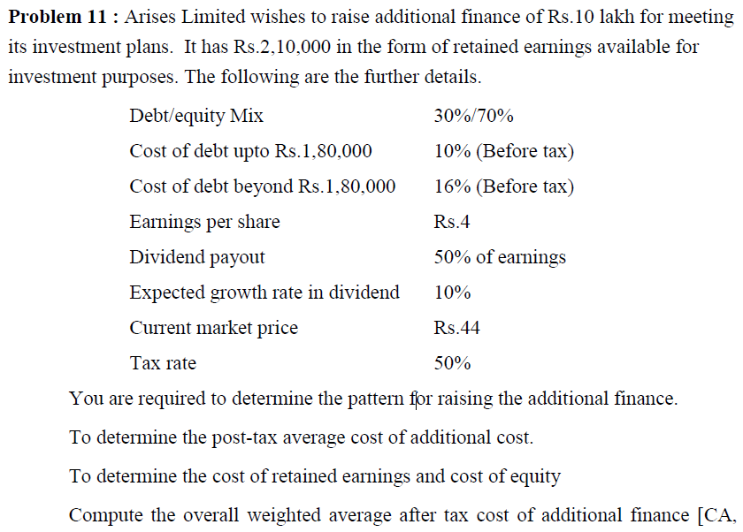

3. A company is considering an investment proposal to install new milling controls at a cost of Rs.50,000. The facility has a life expectancy of 5 years and no salvage value. The tax rate is 35%. Assume the firm uses straight line depreciation and the same is allowed for tax purpose. The estimated cash flows before depreciation and tax from the investment proposal are as follows:

|  |  |
| --- | --- |
| Year | CFBDT |
| 1 | 10,000 |
| 2 | 10,692 |
| 3 | 12,769 |
| 4 | 13,462 |
| 5 | 20,385 |

COMPUTE THE FOLLOWING:

* + 1. Payback period
    2. Average rate of return
    3. Internal rate of return
    4. Net present value at 10 percent discount rate
    5. Profitability index at 10 percent discount rate